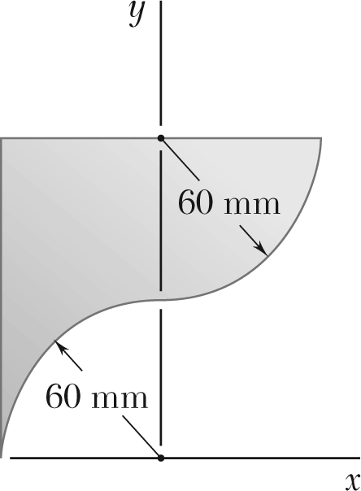 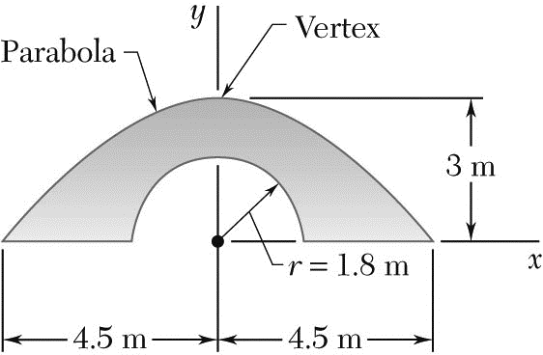

Locate the centroid of the plane areas shown

ASSIGNMENT # 5-2 Due on 16/12/19 Student # …………… Name ………………………

**STATICS** ***UDM ENGR 3120*** - ***BUCT MEC 1701-1703*** ***CHAPTER 5 – Centroids, Center of Gravity*** Student Name……………….........